RESUM OF
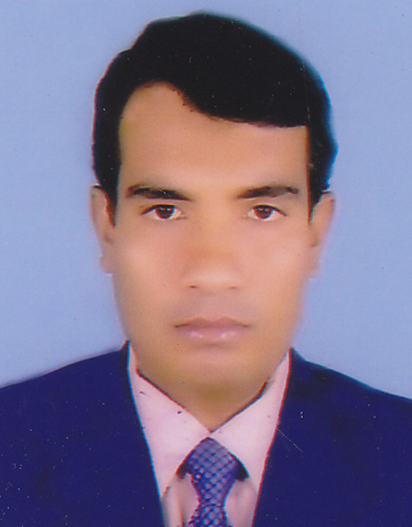
Md.Amrun Hossain
Contact No:+8801711169297,+8801917977602
E-mail: md.amrunhossain@yahoo.com
Career Object:
To work in an organization that will offer me a participatory job environment, well-remunerated,
creative and for exposing my skills, abilities and determinations to face the challenges of real life
situations. Also obtain a challenging positions in a reputed institution that will allow me to expand
upon my education and to continue accumulate knowledge.
Employment History:
Present job:
Presently serving as a Technical Officer in Field Operation Department under Technical Division MSD OTB Project (served 27th April,2008 to till now) in HUAWEI TECHNOLOGIES (BANGLADESH) LTD. Sharif Mansion (2nd floor)11, Mohakhali C/A, Dhaka-1212.
Job Responsibilities:
• Maintenance fit Operation of Power related equipments such as Diesel Gen sets Brand SDMO, ONIS VISA, TEMPEST ,Forestcity and FG WILLSON, Paramac Generator with servicing and Maintenance alsoTroubleshoot (7KVA, 20 KVA, 22 kva,30 KVA).
• Maintenance and Installation: Indoor Sub Station installation for Step down Transformer, LBS, PFI, MDB, SDB, and Rigger Feeder BBT Bus bar etc.
• Maintenance & Operation of Power related equipments such as AVR (Grameen Power Glaxy), Rectifier unit & Battery Bank (EMERSON BRAND, PS48300/30)
Achievements:
• Installation & Commissioning (Diesel Generator)
• Operation & Maintenance (Diesel Generator)
• Troubleshoot of Diesel Generator
Previous 1ob# 1
Served as a Service Engineer (serve 01 -01 -2000 to 20-04-08) in
Motor ASSOCITATES.faruk Chambe(7th floor),1403,SK.Mujib Road,Agrabad,Chittagong,Bangladesh.
Responsibility:
• Installation & Commissioning (Diesel Generator)
• Operation 8t Maintenance (Diesel Generator)
• Troubleshoot of Diesel Generator
Previous 1ob # 2 :
!
Served as a Sub-Assistant Engineer (served -08-1997 to 28-12-1999) in HOTEL SAINTMARTIN, Agrabad ,Chi ttagong, Bangladesh.
• Maintenance and Installation: Indoor Sub Station Installation for Step down Transformer, LBS, PFI, MDB, SDB, and Rigger Feeder BBT Bus bar etc.
• Maintenance & Operation of Power related equipments such as a Diesel Generator.
• Maintenance & Operation Central AC,Window type & Selling type AC.

ACADEMIC ACHIVEMENT:
SL | Name of Education | Name of Institute | Board | Subject | Passing Year | Result
1 | Diploma Engineering | Chittagong Polytechnic Institute | BTEB | Electrical | 1998 | •jnd  Division
2 | Secondary School Certificate | Shalnagar Modern Academy | Comilla | Arts | 1994 | •jnd  Division
Personal Data; Md. Amrun Hossain Father's Name: Abdur Rashid Mother's Name: Shamson Nahar Date of Birth : 20th August, 1977 Nationality : Bangladeshi (by birth) Religion : Islam
Permanent Address: Village: Azizullpur Post: Dinmonir Hat Police Station: Sadar District: Noalkhali Bangladesh.
Mailing Address:
House #46/1, Road by
Lane # 4, Charer Hat, Towon Khalishpur, Khulna-9000.
Bangladesh.
LANGUAGE PROFICIENCY
Road, write and speak fluently in English.
PEFERRENCE
Mahbubul Alam
Engineer, Field Operation
UCE Telecom Solution Ltd.
Road # 108, House # 22, Suite # 1-F, Gulshan, Dhaka-1212.
E-mail: mhbubul.alam@uceintl.com
Cell: +8801198014104
Confidence;
I am energetic young and excellent an out going pleasant personality and strong
inter personal skill an ability to work at high pace on ones own imitative.
Signature
Md. Amrun Hossain

